Contents
Club Recognitions and Awards 2
Roy Acree 3
Scott Auer 3
Rick Beauford 4
Sam Belcher 5
Darl Champion 6
Ty Cobb 6
Raymond Coffman 7
Rick Crain 7
Sean DeHaan 8
David Van Dyke 9
Jerry Epps 9
Jimmy Freeman 9
Cherry Gipson 10
Tim Gowens 10
John Hubbard 11
Anthony Iorillo 12
Lamar Jones 12
Bill Keappler 13
Matt Martin 14
Jeff Mason 15
David McGinnis 16
Don Parkerson Jr. 16
L. A. Philips 16
Aaron Schwartz 18
Narayan Sengupta 19
George Spears 20
2009-2010 District Governor Roy Strickland 21
Jordan Maxwell Shivers 22
Jeffrey Tucker 22
Snyder Turner 23
David Van Dyke 24
Sam Whitfield 24
David W. Wine 25
Harold H. Wolfe 25
Kevin Young 26

Club Recognitions and Awards
THE ROTARY FOUNDATION

Individual Recognition

Arch C. Klumph Society
Samuel R. Whitfield

Major Donor
[…]

Multiple Paul Harris Fellow
[…]

Sustaining Member
Roy Acree, Brenda Romanchik, Sean Tintle

Bequest Society
Jimmy Freeman, Sam Whitfield

Club Recognition

100% Paul Harris Fellow Club - 1st in the District in 2004!

100% MULTIPLE Paul Harris Fellow Club - 1st in the District in 2014!

100% Sustaining Member Club 2004, 2005, 2006, 2007, 2008, 2009, 2010, 2011, 2012, 2013, 2014, 2015

AWARDS

The Rotary Foundation Citation for Meritorious Service
Roy Strickland 2005-2006

Rotary International Avenues of Service Award
Sam Whitfield 2006-2007, L.A. Phillips 2008-2009

Rotary International Presidential Citation
Roy Strickland 2009-2010

DISTRICT GOVERNORS
Gardner Potter, Lee Howard, Roy Strickland

Roy Acree
Roy is a Cobb County native; born in Marietta, and attended Marietta High School.
Roy began his fire service career in the City of Smyrna in 1990. He was appointed as an Engineer in 1999, as a Lieutenant in 2000, Deputy Fire Chief in 2008, and eventually to the position of Chief in 2014. He also holds the position of Emergency Management Director.
Roy is a Nationally Certified Fire Officer and is a Master Certified Emergency Manager through the Georgia Emergency Management Agency. He holds numerous certifications from the Georgia Fire Academy, the National Fire Academy, the Emergency Management Institute, and both the Federal and Georgia Emergency Management Agencies. He has been certified as an EMT since 1989, a Smoke Diver since 1991, and a Paramedic since 1993.
Roy is a member of many professional organizations including the Georgia Firefighters Association, International Association of Fire Chiefs, International Society of Fire Service Instructors, Emergency Management Association of Georgia, and the Georgia Mutual Aid Group. He has been the Area 7 (Metro Atlanta) Operations Chief for the Georgia Mutual Aid Group for the past 5 years. Chief Acree is also an adjunct instructor for the Georgia Public Safety Training Center and the current President of the Smyrna Public Safety Foundation. He resides with his wife and five children in Powder Springs.

Scott Auer
Scott was born in Eden, North Carolina and moved to Asheville, North Carolina when he was four years old. He enjoyed spending time outdoors and worked in the family garden most Saturdays. Scott was also active in athletics from age nine and played various sports, including football, baseball, basketball and wrestling. He moved to Atlanta in 1993 and has lived in Smyrna since 2001.
Scott attended North Carolina State University where he obtained a BA in Religion and Philosophy. He also played football there and was captain of the football team his senior year. After graduating from college, he became interested in home building and began a career in that field in 1990. For the past 19 years he has worked for several small custom builders in the Asheville area and a large builder/developer in the Atlanta area, where he worked for 12 years. In 2008, Scott started his own residential construction company, CrestHaven, LLC and is currently focused on residential remodeling, additions, basement finishes and outdoor living projects.
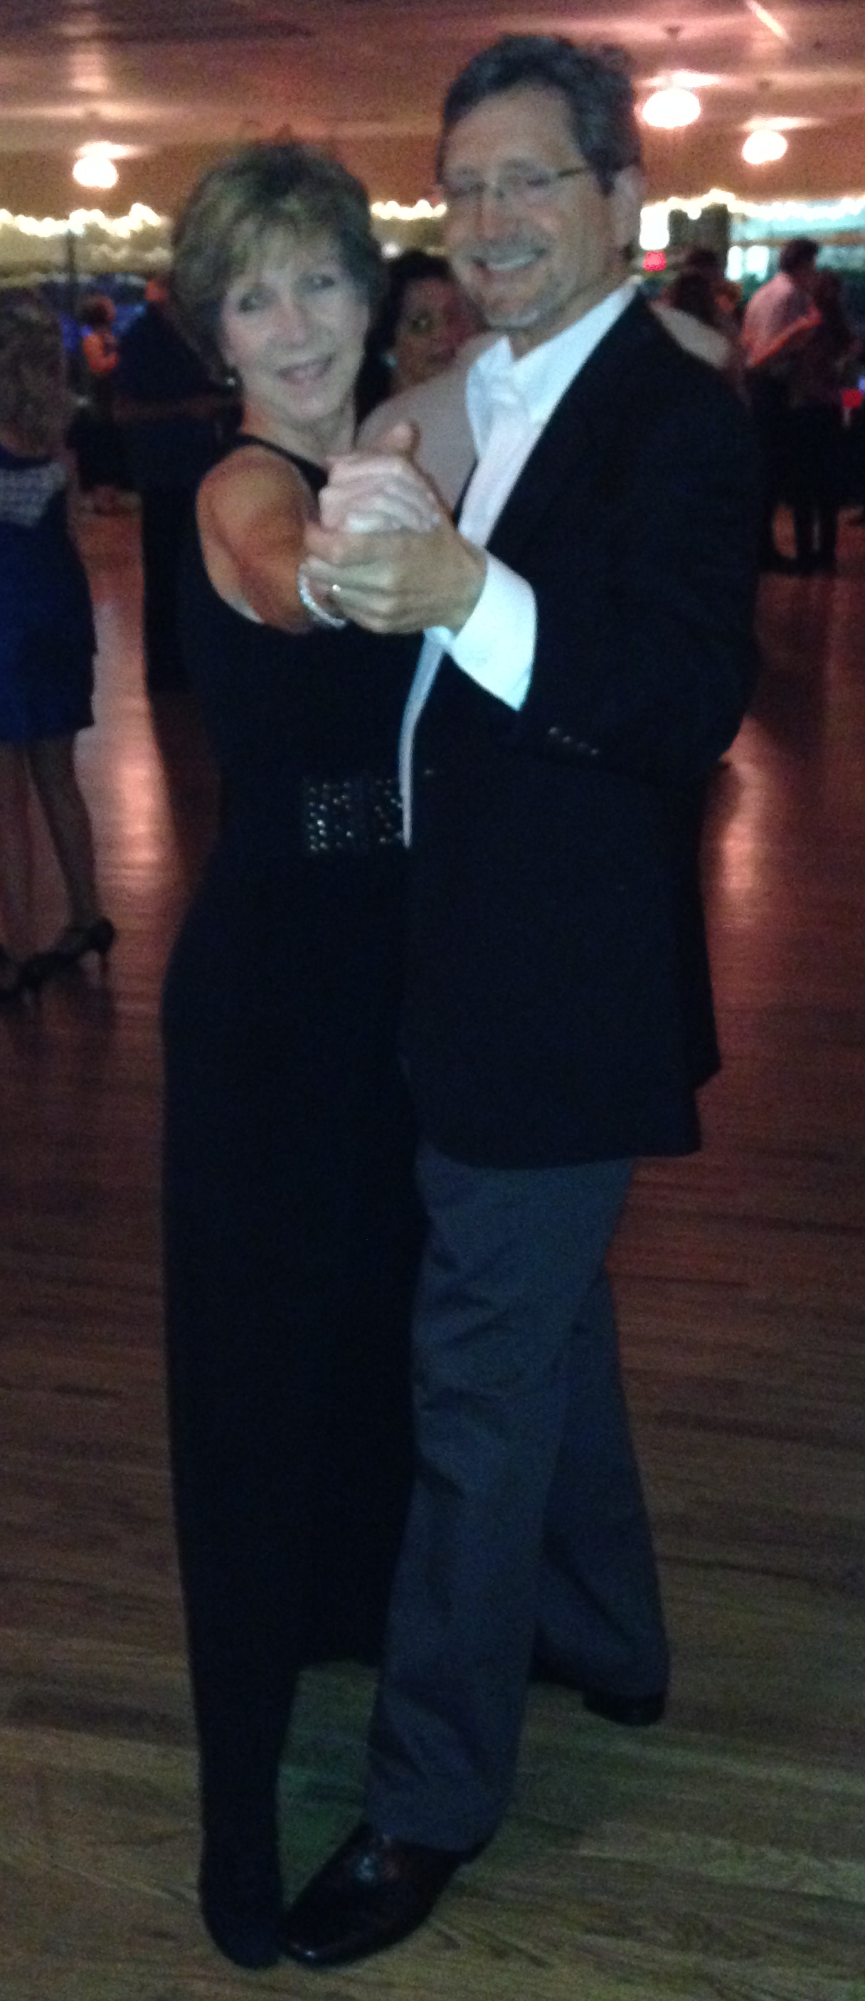
He was married in 2007 and recently they gave birth to a lovely daughter. Scott enjoys outdoor activities such as hiking and biking, sporting clays, bird hunting and amateur landscaping at their residence.

Rick Beauford
Rick’s parents both served in the military and as such, he never really had a place to call home until his father finally retired in Little Rock, Arkansas. In his junior year of high school, his father took a job in Hot Springs, AR, which is where Rick completed his high school diploma in 1971. Rick graduated with a B.S.B.A degree in Accounting from Henderson State University in 1976. He passed the CPA exam in 1978 while attending graduate school at night at the University of Arkansas at Little Rock, where he completed his MBA in 1980. Rick worked as a Controller and CFO for several prominent family owned businesses in Little Rock. Rick was previously married and has one daughter, Jennifer, who will be 32 years old later this year. He and his daughter share the same birthday.
Rick met his current wife Donna in the late 90’s. Donna lived in LaGrange, GA, so they maintained a long-distance relationship for several years. Rick moved to LaGrange, GA in 2001 and they were married. He took a job as CFO for Multicast Media and joined the LaGrange Rotary Club. In 2005, the company relocated their headquarters to Circle 75 and Rick & Donna moved to Peachtree City. Rick became a member of the Vinings Rotary Club, where he served as Treasurer for 2 years and Foundation Chair for 5 years. After surviving 5 years of the grueling I-285 commute, they wised-up and moved to Mableton.
When Multicast was acquired by a global digital media company, Rick formed Regent Accounting, LLC, a full-service accounting firm specializing in accounting, tax & CFO services. After successfully acquiring Barrett-McLeod Business Services (a long-time Smyrna business) earlier this year, he opened his new office in the heart of Smyrna, located at the intersection of Concord Road & Dunton St.
Rick and Donna live in a Wieland sub-division townhome located in Mableton with their two elderly black labs. They enjoy spending time with family, friends & each other. They have been taking weekly dance classes for over 4 years and spend most of their weekends dancing around town. Their favorite dance spot is the American Legion Post #160 located in Smyrna!

Sam Belcher
I was born and raised on a working farm in Perry County Alabama, approximately 45 miles south of Tuscaloosa. Yes, I plowed a mule and picked cotton as I was growing up. I attended a small high school in Marion Alabama. We had 26 members of the Senior class. After high school, I attended Auburn University where I obtained a BS degree in Wood Technology (wood engineering) and minored in Industrial Engineering.
I enlisted in the U.S. Army Reserve. After active duty was completed, I was employed by one of the larger furniture manufacturers in Martinsville, VA as Quality Control manager. Then was employed by Reichhold Chemical in 1966, as a technical representative in the development of the chemistry necessary for success in the development of southern pine plywood industry throughout the Sixties.
Worked as a technical salesperson with Reichhold and later as a National Account Manager for International Paper Chemical Division until retirement. At that time, I started a second career in auctioneering and real estate. I currently hold active licenses as an auctioneer in GA, FL, and AL. In addition, I hold licenses as real estate broker in GA, FL and AL as well as real estate instructor licenses in FL and AL. I teach auctioneering at Troy University Dothan twice each year as well as Continuing Education for active auctioneers.
I started my auctioneer career as a professional fund raising auctioneer. I have directed fundraisers for American Heart Association’s Heart Ball, the Cancer Society’s Cattlemans Ball, private schools, Boys and Girls club, Big Brother Big Sister club, Chambers of Commerce and public libraries. I am still active in both auctioneering and real estate.
I was an active Toastmaster for 6 years and was active Rotarian in Panama City Beach FL. for 4 years.

Darl Champion
Darl was born and raised in Fayetteville, North Carolina, where he graduated with a B.A. in Political Science from Methodist University in 2004. He then attended Mercer University’s Walter F. George School of Law. During law school, he was a Managing Editor of the Law Review, a member of the Moot Court Board, and the recipient of the Faculty Award for Outstanding Senior. After receiving his J.D. from Mercer in 2007, he spent two years clerking for the Honorable Hugh Lawson, a federal district court judge in the Middle District of Georgia.
Darl and his wife Julia moved to Smyrna in 2009 when Darl accepted a job at the law firm of Freeman Mathis & Gary. In 2010, Darl went to work at Warshauer Law Group where he began to exclusively represent people in serious injury and wrongful death cases. In June 2014, Darl started his own law firm, The Champion Firm, P.C., where he continues to specialize in representing people who have been injured or lost a loved one due to someone else’s negligence.
Darl and Julia were married in 2004, and they have a daughter, Elizabeth, who was born in 2012. They live in Smyrna’s Woodbridge Crossing with their dog, Belle. Darl enjoys being active in the community and volunteering his time to help others. He is also a diehard Steelers fan, and he enjoys reading and traveling.

Ty Cobb
President-AAA Signcrafters, Inc.
Deacon - GracePointe Marietta Baptist Church
Wife-Christine F. Cobb-Account Sales Executive-Graphic Solutions Group
Daughters- Erica C. Jarman of Savannah, GA - Emily C. Chonko of Loganville &Allison E. Cobb
Granddaughter -Vada Chonko; 2 Grandsons coming soon
All my daughters will be graduates of Georgia Southern University. Allison graduated May 2010.
Born and raised in Cobb County. Graduated Wheeler High School, Art Institute of Atlanta
Enjoy trying to play golf. Love Georgia Bulldogs and College football. Happy to be a Rotarian.

Raymond Coffman
Raymond Coffman, a native of Washington DC, has been a resident of Cobb County for 30 years. As an ordained minister he is Chaplain and Manager of Pastoral Care at WellStar Cobb Hospital. He holds a Bachelor’s Degree in Theology and a Master’s Degree from Liberty University in Pastoral Care & Counseling.
Raymond serves a 385 bed hospital and facilities a Grief Support Group open to the community as well as a monthly Cancer Support Group. He is a member of Wellstar Health System’s Ethics Committee.
He is honored to serve as Pastor to the Historic Log Cabin Community Church in Smyrna. Log Cabin is one of the first Non-Denominational Churches in the Southeast. He and his wife Barbara reside in West Cobb County. His son Clark is a student attending Syracuse University.
He adores travel having visited over 20 countries and over 25 states. He loves to cook and entertain, practices Yoga and enjoys speaking a bit of French and Spanish.
Raymond has been a member of the Smyrna Rotary for over 18 years.

Rick Crain
Rick Crain was born in St. Louis, Mo. and his corporate career took him to San Antonio, Princeton, Philadelphia, and Atlanta. After a successful corporate career in which Rick started up two regional data centers, turned around another, and merged two regions together, he left to start his own company, bringing his experience and innate knowledge as a Business and Executive Coach with ActionCOACH Business and Executive Coaching and the Center for Executive Coaching. Rick specializes in helping business owners grow their business and create an exit strategy and helps executives to excel in their careers.
Since entering his coaching career Rick has been named The Most Inspirational Coach in Georgia for 2007, The North America NetWORK Coach of the Year in 2008, and the International Action Man Award in 2008. Rick is twice named on the top 100 coach’s list in the world by the International Business Coaching Institute.
Rick holds an undergraduate degree in Business Management from Peirce College. He has master certifications in Project Management and Strategic Organizational Leadership. He holds three coaching certifications; a business coaching certification from the IBCI, executive coaching certification through the IBCI and CEC. Education is constant for Rick to be an effective leader in his profession.
As a loving Father, Rick has two children, Rick, Jr. and Maria, teacher and nurse practitioner, one living in Philadelphia and one in Dallas. He has one grandchild, William. Rick is an avid sports fan and coach, plays baseball, and has a heritage of two uncles who played for the St. Louis Cardinals minor league system.
Rick is involved with his Rotary Club in Smyrna, GA and leads the Rotary Youth Leadership Awards program and serves as a counselor at the annual camp. Rick also is a Paul Harris Foundation member.

Sean DeHaan
Sean was born and spent his formative years in Guyana, South America. His family immigrated to the United States in the late 1970’s and settled in Lexington, KY where he attended junior high, high school and college.
During summer breaks while in college he ran his my own business marketing books published by the Southwestern Company. His last summer marketing books, Sean ran an organization of 40+ students from various colleges in the southeast. After graduating from the University of Kentucky, he joined Northwestern Mutual as a financial rep and relocated to Atlanta in 1995. At Northwestern, Sean was active on two national boards, the Financial Reps Association and the Association of Advanced Professional Studies.
He started DeHaan Wealth Management to provide clients with unbiased, objective comprehensive financial planning. Prior to starting his own firm, Sean worked as a Financial Advisor at Merrill Lynch providing wealth management solutions to clients.
Sean has always been active in the community. Some of his past community involvement include volunteering with the Junior Chamber of Commerce, Soccer in the streets, Junior Achievement, Boy Scouts of America, CobbFC, Woodruff Arts Center and the United Way. He has played competitive soccer with various teams through his life. He has also played internationally in Germany, Malta and the US Virgin Islands.
Sean and his wife Sonya are residents of Smyrna. They have two children Olivia 8 and Winston 5. He has always been active in various sports and enjoys sharing those activities with his children.

David Van Dyke
I am a native Atlantan where I grew up in Cobb County and graduated from Walton High School. I spent several years in my twenties living in Colorado working in multiple positions but mostly perfecting my ski technique before coming back and focusing on my career at Piedmont Graphics, our family owned business. My father started the company 30 years ago in his garage and it has grown to 50+ employees in a 50,000 square foot manufacturing facility. He retired in 2001 and since taking over, I have added OnTrack, a software company, PG Print.com, an online printing company, and BrandThisStuff.com to our family of companies.
I presently reside in Woodstock and have two children, a daughter Caroline, and a son, Jack. I love playing golf when I can find the time and spending time at the beach.

Jerry Epps
Dr. Jerry Dean Epps has a Master’s Degree in Sociology and a Ph. D. in Human Services with emphasis in Psychotherapy. He lives in Marietta Georgia with his wife Beverly and two fun dogs. He enjoys landscaping in his beautiful back yard.
His passion is Economic development to alleviate poverty in the developing world. He funds micro business in Haiti and has a full time supervisor watching over the growing number of projects there. Recipe for Hope is his life work, and represents his commitment to eradicating generational and socially accepted poverty in the developing world. Recipe for Hope is a practical plan for local business owners and investors to focus on a small target area of poverty and bring intense commercial activity there that will lift the standard of living for all.

Jimmy Freeman
Jimmy Freeman was born in Union County Georgia and attended Young Harris College. He came to Cobb County with the desire to succeed and not much else. Starting at the Bell Bomber plant in 1955, he worked at many different jobs (some concurrently) to feed his hungry children. On his road to success Jimmy drove a truck, fathered 5 children, owned and drove a Taxi Cab, operated a used car lot and purchased a deep hole on South Cobb Drive which nobody else would touch. He filled the hole and built a GMC Truck Dealership there.
After opening the GMC store, Jimmy expanded that dealership to light, medium and heavy-duty trucks. He started the Freightliner Heavy Duty truck dealership in Atlanta. From the early 60’s, he opened several new vehicle dealerships in the Atlanta metro area including such makes as Jaguar, Jeep and VW. At the same time, Jimmy started Fun Center to sell boats and recreational vehicles. After selling the GMC and Freightliner dealerships, Jimmy opened the Atlanta Kenworth Dealership. Over the years, he has been involved in the organization, operation and sale of over 40 different franchises. All have been successfully launched, operated for many years and were profitably sold to larger dealer groups. Mr. Freeman is also an investor in several other industries including commodities, finance, retail, equipment, real estate and agriculture.
Jimmy joined Smyrna Rotary Club in January 1964.

Cherry Gipson
Cherry Gipson was born in New York City and lived in Memphis Tn. She moved to Georgia in 1991. Cherry was involved in the field of alternative education for twenty-two years and an administrator for twenty of those years. Cherry was Principal of the Cobb & Paulding Counties Adult Education Centers from 2009-2014. Cherry was also Principal of Cobb County’s Alternative School from 2000-2008. In 2008, after the closing of the alternative school, Cherry worked in the Cobb County Student Support Division and oversaw the implementation and transition of the district to Ombudsman (which was hired to oversee the alternative program).
Cherry was Vice-President of the Georgia Association of Alternative Education and later President. Cherry was also Vice-President (for a short time) of the Cobb Literacy Council. Cherry also served on the Cobb County Work Force Investment Board. In addition, she also served as an advisory member of the Pan Asian Community Service Literacy Council.
She is married to Terry Gipson.

Tim Gowens
Tim Gowens - a Smyrna Rotarian - has owned and operated Metro Wheels since its beginning in 1989. The company has seen tremendous growth since this time and we are currently striving to accomplish our vision statement:
Our Vision...
To become the premier wheel repair and replacement center in the Southeast, where success is driven by excellence, fixed on quality and fueled by raving fans.
Metro Wheels collectively employs more than 100 years of experience in the wheel repair and replacement industry. We have been in business since 1989. This leading body of knowledge and years of being in business gives you the advantage and peace of mind that you are going to receive the highest quality products and services available in the industry. We are suppliers of new and used factory original equipment wheels, hubcaps and centercaps. We have engineered and built a state-of-the-art wheel repair and reconditioning plant. There are over 10 thousand part numbers and over 75 thousand items in stock at competitive prices. Metro Wheels is truly your One Stop Wheel Shop. We are eager to assist you! Our sales consultants - who are driven by excellence, Fixed on quality, and Fueled by raving fans, are the best in the industry and chances are we will have it in stock. But if not, we can repair your damaged wheel.

Interests: Classical guitar (actively playing for more than 30 years)
Biblical studies: Studied for the ministry at Baptist University of America
Additional Education: Polytechnic University - Marietta Georgia
Married: 14 years
Children: 2 Beautiful Children

John Hubbard
John Hubbard is a native Atlantan, and has lived in Cobb County since 2000. He graduated from Georgia State University in 1997 and has owned part of Hubbard Insurance, Inc. since 1999.
John has followed in the footsteps of his father and grand-father who were/are also in the insurance industry. John has been a member of Smyrna Rotary since 2001 and has served multiple terms as Secretary.
John and his wife Katherine have been married since 2000 and they have two boys: Jack and Charlie. Jack is in year round tennis at Olde Towne/Ginepri and Charlie is in year round baseball at Mt. Paran/Next Level. Katherine has a Master’s degree in Special Education and is an elementary school teacher in East Cobb. John enjoys participating in sports like tennis, softball and golf. He has coached youth soccer, basketball and/or baseball since 2008. His family enjoys spending time at their lake house in Dublin, Georgia when they get free time.

Anthony Iorillo
The grandson of an artist and metallurgist and son of a financial planner and substance abuse counselor, naturally Anthony is an Architect. But Anthony’s passions are for God, his family, church and coaching youth sports. Anthony’s father, John was the first generation born in the United States; Anthony’s grandparents emigrated from Italy through Ellis Island. John met Anthony’s mother, Lynnette in California where Anthony was born. Anthony’s mother almost died in labor and his parent’s plan of having a big family was changed; Anthony is an only child.
Anthony was born in Orange, California and lived in West Covina, California before moving to Pheonix, Arizona. When Anthony was five his family moved again to Marlboro, New Jersey and reunited with his father’s side of the family that lived in New York. Realizing that the colleges that Anthony wanted to attend were in the South, Anthony’s father accepted a position in Georgia and the family relocated to Marietta in 1986.
Anthony graduated Joseph P. Wheeler High School in Marietta, Georgia. Anthony went on to the Georgia Institute of Technology to study Architecture, obtaining his pre-professional degree, a Bachelor of Science.
Anthony took a year off from school and worked for an Architect in Atlanta. In that year Anthony, met his future bride Penny Thomas, a graduate of McEachern High School and Kennesaw State University. After graduating from Virginia Polytechnic Institute and State University, Anthony and Penny married and settled in west Cobb County. They have three wonderful children: John “Trey”, Thomas, and Victoria “Tori”. Penny is a teacher and a breast cancer survivor. Anthony and Penny are active at Roswell Street Baptist Church. Anthony enjoys coaching youth sports and relishes coaching his sons in football and anticipates coaching his daughter in soccer.
Anthony joined rotary in 2008, sponsored by his good friend Tim Gowens. Anthony was drawn to rotary by the organizations good work and the great members in the Smyrna.

Lamar Jones
I was born in Tignall, Georgia, a small town located one hour north east of Athens. I graduated from Washington Central High School, Washington, Georgia in 1970, Barber Scotia College, Concord, North Carolina in 1978 where I earned a Bachelor of Science Degree in Biology, and from the University of Phoenix, 1988 where I earned a Masters of Business Administration. After finishing my undergraduate degree I joined the United States Air Force, and worked as a medic doing my four year tour in Albuquerque, New Mexico. After honorably completing my enlistment I worked as a Psych Tech on the Vietnam Veterans Agent Orange Study at Lovelace Medical Center in Albuquerque.
I am the Founder President and Owner of Key Maintenance Supply Inc., which is a Sanitary Supply Sales and Distribution company. I have been in this industry for 24 years. I began working in the industry while living in Albuquerque for National Sanitary Supply in 1988, which was later bought by Unisource Worldwide which was later bought by Georgia Pacific. While working for the aforementioned companies I managed area locations in Indianapolis, Indiana and Detroit, Michigan. In 2001 after much company downsizing it was decided the company could go on without me, and I decided I had to go on without it. Thus, Key Maintenance Supply was born.
I enjoy golf, fishing, motorcycles, cows, gardening and helping others. My favorite charitable organizations are the YMCA and my church, Elizabeth Baptist.
My wife Debbie and I live in Lithia Springs, Georgia. I am happy and proud to be a Rotarian and am looking forward to doing great things with the Smyrna Club.

Bill Keappler
Bill Keappler was born in Atlanta Georgia at Crawford Long Hospital and has lived in the Atlanta area all his life. Bill is a graduate of the University of West Georgia with a B.S. in Business Administration/Accounting and was a member of the varsity swim team. Bill met his wife Carolyn at college and they were married in June, 1970.
Bill and Carolyn have lived in East Cobb since 1980 and are active members of Eastminster Presbyterian Church. They have two married daughters, Amy and Kristina, and have a grandson Ryan and granddaughter Taylor. Carolyn has been a preschool teacher for over 20 years. Bill is President of Quintus Corporation and is active in apartment management and land development. He is a licensed real estate broker, private pilot and is involved in investment real estate and remains active in various civic and business organizations.
Bill joined Smyrna Rotary in April 1986 and served as club president in 2007-2008. He has maintained perfect attendance since joining Rotary in 1986 and has served in many leadership positions. Bill is a Paul Harris Fellow, a Charter member of the Paul Harris Society, a Kendall Weisiger Fellow and a GRSP Sustaining Member. Carolyn is a Paul Harris Fellow and she and Bill are Rotary Foundation Major Donors. Bill is the recipient of the Frank E. Bentley GRSP Leadership Award and was named Smyrna’s Rotarian of the Year in 1997-1998. Bill has been Smyrna Rotary’s GRSP Chair and Host Family for many years.
Bill’s hobbies include hiking, fishing, gardening, water sports and coin collecting. Bill and Carolyn enjoy traveling and visiting new cities and countries. They also enjoy spending time and playing with their grandchildren.

Matt Martin
Matt grew up in Lilburn and attended the University of Georgia, where he met his beautiful wife, Autumn, and discovered a passion for the life and mission of Jesus. After college, Matt and Autumn moved to Pasadena, California where Matt earned a Master of Divinity from Fuller Theological Seminary. Matt and Autumn now live in Smyrna with their three above-average children.
In addition to serving in various ministry roles from youth minister to pastor, Matt has also served in a variety of cross-cultural settings in a Korean church and a Taiwanese church. Matt was a certified candidate for ordained ministry in the United Methodist Church, where he served as the local pastor for Montpelier United Methodist and director of the Georgia College Wesley Foundation.
But Matt’s real passion is seeing God change the lives of young people. In 2011 Matt joined InterVarsity Christian Fellowship to plant a new chapter at Kennesaw State University. Matt has a passion to see the 26,000 students at KSU discover a life of meaning and purpose and to become world changers in their community. Recently, Matt was awarded the highest score and selected as one of twenty chapter planters for InterVarsity Christian Fellowship’s National Planting Cohort 2013-2016, which includes a $30,000 grant. The training and support from this Cohort will ensure that the new InterVarsity chapter at KSU will become a well established and effective ministry for years to come. Matt was also honored to become a part-time instructor at KSU where he teaches two freshmen seminars during the Fall semester.
Matt takes pride in being a devoted husband and father. A minimalist at heart, Matt enjoys simple living, outdoor activities, and new challenges. Matt looks forward to years of building community and serving his neighbors through Rotary. And if you believe Matt is half as great as this bio states, then he has a fishing story to tell you!

Jeff Mason
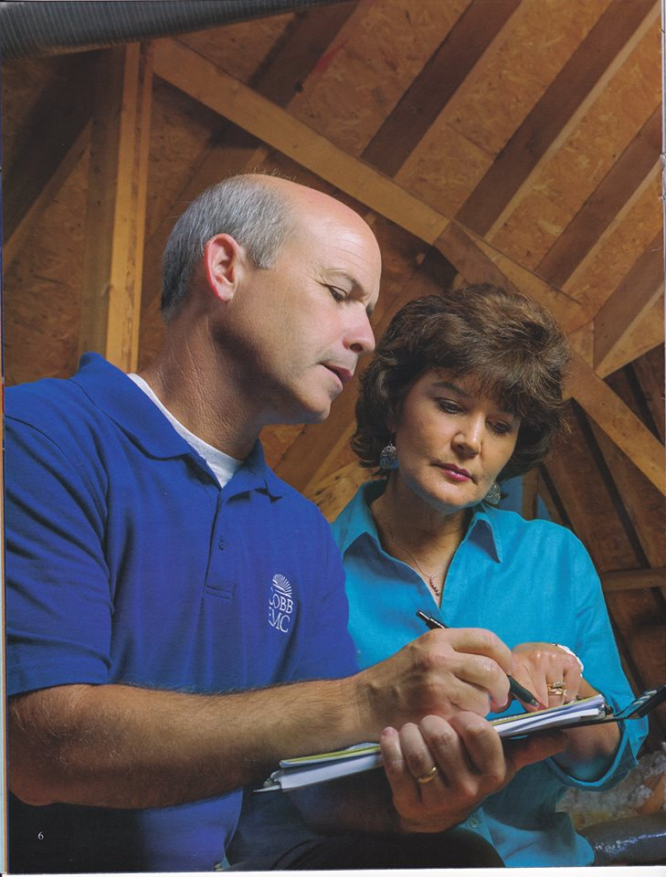
Jeff was born on November 3, 1962 in Columbus, Georgia. From an early age he can remember being fascinated with airplanes. “Growing up, our house was located on the final approach to Columbus Metropolitan Airport so I always got to see a wide variety of aircraft. My favorite was a WWII P-51D that would come by on occasion. To this day the sound of a Rolls-Royce Merlin will make the hair on the back of my neck stand up.”
He went to Embry-Riddle Aeronautical University in Florida with the intent of becoming a military pilot. He got his private pilot’s license but flying for the military was not to be. He finished his Bachelor of Science in Business at Columbus College, in Columbus, Georgia.
About this time he met his wife Diane and they have two boys, Austin 14 and Spencer 10. They have lived in Marietta for 16 years. He has worked for Nabisco, BellSouth Cellular Corporation, and at Cobb EMC for the past 8 years. He and his family enjoy camping together, trail riding on dirt bikes, shooting targets, and tinkering with old cars or anything else in the basement.
Jeff is a Paul Harris Fellow, and has served as the club’s Sergeant at Arms.

David McGinnis
Originally from Rome, Georgia, he graduated West Georgia College, now the University of West Georgia in 1971. While in college, he met and later married his wife of 44 years, Marcia who is originally from Cobb County. They have three children, and seven grandchildren. He is president of Habitat for Humanity of Northwest Metro Atlanta, Inc. in Smyrna, Georgia and his wife a retired elementary teacher from the Cobb county school system. David currently serves on the Board of Trustees of the Noonday Baptist Association, as a deacon at the Milford Baptist Church, is a Rotarian, a Gideon and has served on numerous civic organizations and boards.
He has served in numerous capacities in the Rotary Club since joining in 1998. His interest is in the ministry to children.

Don Parkerson Jr.
Don was born and raised in Eastman, Georgia. He grew up playing sports and working in his Dad’s chiropractic clinic. In 1990, Don first moved to the Atlanta area to attend Kennesaw State on a baseball scholarship. After 2 years, he transferred to the University of Georgia and graduated with honors with a Bachelor of Science in Exercise Science. In 1994, he moved to Smyrna to attend Life University and graduated Summa Cum Laude in 1998 with his Doctor of Chiropractic degree.
Don began his chiropractic career in 1997 as an intern at the Humber Clinic in Smyrna and formally began practicing in Spring of 1998. In 2002, he bought the Humber Clinic and Neal Chiropractic to form the combined HP Spine Center, where he remains owner and clinic director. The original Humber Clinic served the Smyrna area since 1951.
Don has been married to his wife, Julie, for 17 years and they have 2 children, Sadie and Micah. They have been Smyrna residents for 20 years and are members of Mt. Paran Church. The Parkerson’s love to spend time as a family, and enjoy coaching and participating in Upward Sports, as well as University of Georgia football games.

L. A. Philips
I haven't done a formal interview of L. A, but here is a little that I know about him. NS.
L. A. Phillips was in the United States Navy during World War II. Specifically, he was on the oil tender "Merrimack." Yes, you've heard that name before since it was one of the first ironclads that bore that name, and then made it famous at in the "Monitor versus Merrimack." In any case, his ship carried 7 million gallons of aviation fuel. That's some pretty explosive stuff. Their purpose was the provide the liquid to the Essex, Bunker Hill, and several other aircraft carriers that made up Task Force 58 during World War II. L. A. even went ashore at Hiroshima several weeks after the atomic bomb was dropped. [Submitted by Narayan Sengupta.]
The following is cited from the Marietta Daily Journal:
"L.A. Phillips and Emma Lene Phillips, started the exterminating and pest control company [Northwest Pest Control] in Atlanta in 1951. [Steve] Phillips says his parents started the venture as a “mom and pop” side business to supplement his father’s income as a graveyard shift railroad switchman. “He didn’t really have a dream of growing it, he was just providing for his family,” Phillips said.
With his mother answering the phones and his father performing the exterminating services, the business grew nonetheless.
[In 1974], they moved the business closer to the family’s Smyrna home to a building on Cobb Lane, parallel to south Cobb Drive... During the late ’70s, with the residential construction industry booming in Cobb County, the company focused on new construction treatment and growth resulted.
In 1996, [their son Steve] Phillips assumed the role of president and CEO, and the plan he implemented has netted yearly growth for 18 consecutive years, culminating with 2012 revenues of $33.5 million. The company now has 19 offices and service centers throughout Georgia and Tennessee, including three in Cobb County. Phillips purchased the 32,050-square-foot Marietta corporate office and customer support center on Kennesaw Avenue in 2004. Phillips’ mother died in 2006, but his father still works a few days a week. Today, Phillips leads a team of 350 employees

Aaron Schwartz
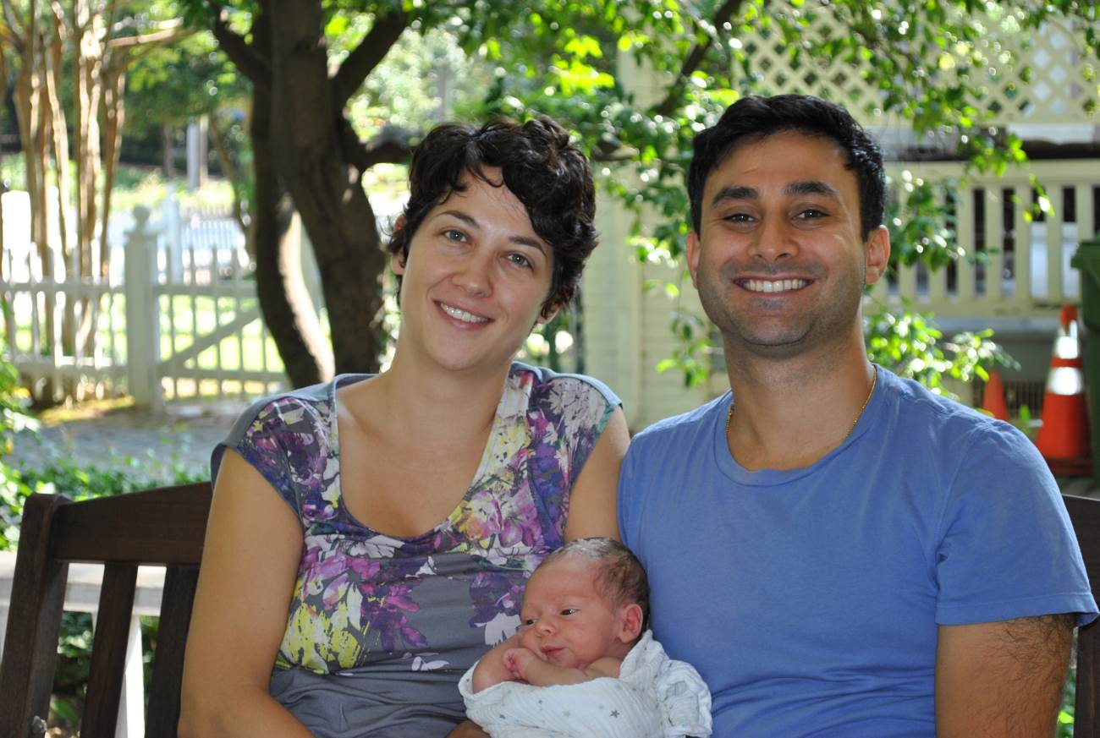
Hi there! I am honored to be a member of the Smyrna Rotary Club. I am the owner of Schwartz Dentistry for Children and Young Adults, in Smyrna, and am a Board Certified Pediatric Dentist and a Diplomate of the American Board of Pediatric Dentistry.
I was born in New Jersey, attended college in Connecticut, and received my dental training at Columbia University, in NYC. I had the amazing opportunity to take the helm of this long established pediatric dental practice in Smyrna, which was formerly owned by Dr. Ted Aspes.
The Smyrna Rotary Club offers me the opportunity to be involved in this wonderful community, outside of my office. The new friendships and excellent lectures the Rotary Club offers carry great weight in my continued aspiration to always lead a life that positively impacts the world around me.
I am an avid tennis player, love to garden, and enjoy cooking and wine. I am happily married to my wife, Thea, and we share the responsibility of taking care of our obese cat, Pearl. I am a big Yankees fan! Don’t hold that against me. : )
Learn more about my practice at www.SchwartzKidsDentistry.com

Narayan Sengupta
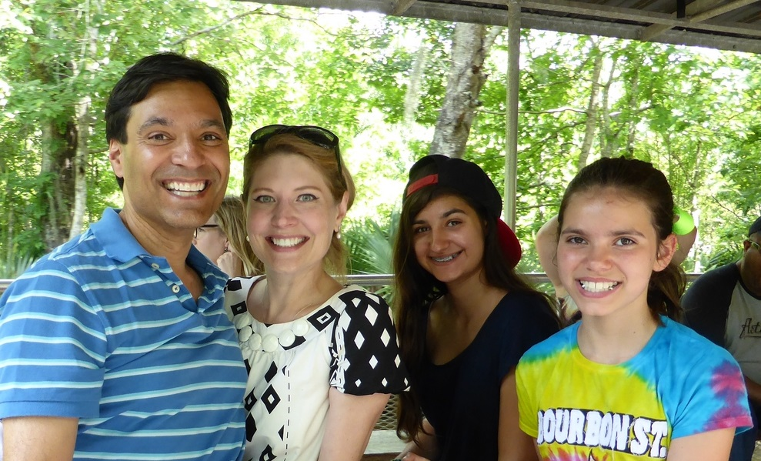
Narayan is the very proud father of his daughters, Mena and Amelie. His wonderful partner is Patricia W. Huff. ☺ Johnny Wilson sponsored him into Smyrna Rotary in 2006. He admires the great work it does locally and globally, fighting polio, building goodwill and friendship between nations, etc. To be with his amazing fellow Rotarian friends is a tremendous honor and each workweek’s highlight.
His architect father emigrated from India in 1958, and his mother is a French fashion designer. Narayan was born in Montreal. They moved to Atlanta in 1970. He also spent four years in Lubbock, Texas, Lafayette, Louisiana and Riyadh, Saudi Arabia before returning to Atlanta in 1983.
He was Star Student at North Fulton High School, has a BA from Emory in history and a minor in Political Science. He was on College Council for two years and ran Residence Hall Association one. He did his MBA at GSU in International Business. He’s been in Cobb since 1990 and Smyrna since 1995.
Narayan worked at IBM, Coca Cola, Alltel, MCI, HP, etc., before founding New Frontiers International in 1998. NFI specializes in business intelligence, data analytics, reporting and database work using MS Access, MS Excel, Tableau, QlikView, SQL Server and Oracle. He has served with the Smyrna Livable Centers Initiative, the Smyrna Educational Task Force, his school’s PTA, founded SuperSmyrna and was Vice Chairman of the National Museum of Commercial Aviation.
His hobby is military history. His French family had nine war veterans including one killed, one POW and one in the Resistance. Brave American soldiers liberated his family in 1944. His Indian family had two noted historians. He started Smyrna’s Veterans Day event and organized a USAF 90th Anniversary in France. He has written history four books and various newspaper articles in his "spare" time. Beyond that, he draws, is an avid photographer, loves architecture and traveling – by planes, trains, automobiles (and RVs) with Patricia, Mena and Amelie. He used to play soccer and has an unrequited love of hockey and skiing. He speaks fluent English, French and Bengali, restaurant menu-level Spanish and Italian, and he has studied some Arabic, German, Japanese, Hindi, Urdu and Russian.

George Spears
I was born in Atlanta Georgia on November 21, 1948 and have lived in Smyrna or Marietta all of my life. My greatest accomplishment was to marry Dianne Holleman on July 10, 1971. We, unfortunately do not have any children, but are very fortunate to have with many nieces and nephews that we are very close to us.
My military career was with the United States Marine Corp where I spent six years in the Marine Reserves.
I have had a great business career that included working at A&P during my school years, Lockheed Georgia, United Republic Insurance Company, United Athletes of America, O’Neal, Jones & Feldman Pharmaceutical Company, and 32 years in the Automobile Industry of which 29 have been Capital Cadillac.
I have been blessed to have been involved in many worthy organizations during my life such as being on the Board of Directors for The Atlanta Chapter for Cerebral Palsy for 10 years, a member of the Fulton County Sheriff’s Department as a volunteer for 14 years, a member of the Multiple Sclerosis fund raising committee with my Aunt who was the Director for over 40 years, a member of the Cobb County Prayer Breakfast Committee, Chairman of the Board of Directors for Calvary Children’s Home and a member of Smyrna Rotary.
I enjoy traveling with Dianne and spending time with our family. Playing Golf is a passion that I do not get to enjoy enough, but look forward to spending my retirement years refining what little game I have left.

2009-2010 District Governor Roy Strickland
Roy Strickland is a native of Atlanta and a graduate of Georgia State University. He joined
Smyrna Rotary in 1996 and served as club President in 1997-1998 - with a second term in
2006-2007.
Roy has twice been named Smyrna’s Rotarian of the Year. He has served as Smyrna’s
Vocational Service Director and multiple terms as Foundation Chair and International
Service Director.
Roy has served the District twice as Vocational Service Chair and multiple terms as Paul
Harris Society Chair. He has served on the membership committee and as Assistant
Governor Foundation Team Representative. He was Foundation Representative to the Cobb
Rotary Council. Numerous times he has been a facilitator at PETS, District Assembly, and at
the Foundation Seminar.
Roy is the recipient of the Sheffield Leadership Award and has been named District 6900
Rotarian of the Year. He has twice been awarded the District Foundation Service Award and
is a recipient of the prestigious Rotary Foundation Citation for Meritorious Service.
Roy met his wife, Suzanne, while both were students at Georgia State. They have lived in
East Cobb for 24 years and are active members of Roswell Presbyterian Church. Suzanne is
heavily involved with volunteer work for Children’s Health Care of Atlanta. Roy and Suzanne
have 2 adult sons, a daughter-in-law and 2 grandsons.
Roy is a Paul Harris Fellow, a Charter Member of The Paul Harris Society, a Will Watt
Fellow, and a GRSP Sustaining Member. He has perfect Rotary attendance since 1996.
Suzanne is a Paul Harris Fellow and she and Roy are Foundation Major Donors.
Roy has been in the automobile business most of his adult life. He now owns a business in Cobb County selling natural stone.
He is also involved with investment properties and remains active in various civic and business endeavors.

Jordan Maxwell Shivers
As a Financial Advisor, Jordan Shivers is driven to provide the sophisticated, personalized wealth management high-net-worth individuals desire. His focus on customized asset management, as well as supporting clients with a “family office environment” for all their financial needs, helps ensure investors receive the in-depth, hands-on guidance that fosters wise decisions. From helping business owners and athletes protect and grow wealth, to assisting retirees and professionals with retirement and legacy planning, Jordan brings diligence and foresight to every financial step.
Prior to joining Merrill Lynch, Jordan supported investors’ comprehensive financial services planning needs, gaining invaluable experience customizing solutions specific to each client. Today, he applies this attention to detail in his client relationships, always working hard to identify opportunities, manage risk and preserve wealth as it pertains to their goals — whether he’s addressing equities, hedge funds, managed futures or other financial strategies. With nearly a decade of financial services experience, Jordan constantly pursues ongoing education, including earning his Chartered Retirement Planning CounselorSM professional designation.
Jordan graduated from Barry College with a bachelor’s degree in finance and economics. He’s an active community member and involved with his local rotary. Jordan is married to Michelle, and they enjoy spending time with their daughter, Madison.

Jeffrey Tucker
Jeffrey Tucker was born in Atlanta, Georgia, in 1967 and grew up in Cobb County. He is a graduate of Duke University, where he was elected to membership in Phi Beta Kappa. With wide-ranging academic interests, he has earned advanced degrees in philosophy from the University of Chicago, and in musicology from Yale University, where he taught music history and music theory in Yale College and was awarded numerous prizes and fellowships for distinguished scholarship. He would love to go to medical school, but his wife will not permit it, declaring six university degrees sufficient for one lifetime.
He joined the Smyrna law firm now known as Cochran & Edwards (formerly Cochran, Camp & Snipes) in 2005. He is Assistant City Attorney for the City of Smyrna, Georgia. His practice includes estate planning, fiduciary administration, and matters of corporate entity formation and governance. He has extensive experience with the creation of testamentary and trust instruments; the planning and administration of estates throughout the probate process; and corporate matters of all kinds, including the special needs of multi-generational family businesses.
Jeffrey joined Smyrna Rotary in September of 2006 and currently serves as Club Secretary; he became a Paul Harris Fellow in 2009. Like Snyder Turner, he has never been Rotarian of the Year, but while there’s life there’s hope. He lives in East Cobb with his wife, Suzanne, and their two sons, Jackson and William.

Snyder Turner
Snyder Turner has been a recent Marietta Citizen of the Year. He ran for office a number of years ago. Now he runs the Cavalry Children's Home.
The following is by Jason Bowman (of South Cobb Rotary?). Cited from http://www.southcobbrotary.org/:
The first vision for a home such as Calvary took place on the streets of Jerusalem, Israel, several years ago while Rev. Ben F. Turner was leading a tour group to Israel. A woman with five small children approached him and offered to sell her baby for ten dollars. When Rev. Turner told her he could not buy the child, she lowered the price to seven dollars, then to five, saying she needed the money to feed her other children. Suffering from malnutrition, each child looked like skeletons with skin merely stretched over them. That experience continued to live with Rev. Turner until 1965.
That year, the Calvary Children's Home moved from a touching experience in Israel to a reality in Smyrna, Georgia. A father and a mother, returning from the grocery store, were involved in an automobile accident. Both were killed, leaving their six children without anyone to care for them. Since it is almost impossible to add six children to an already existing family and budget, the children were separated and placed in four different homes.
As they were being separated, Rev. Turner watched as the children were crying - the younger wanting to stay with the older. He realized the tremendous need for them to stay together, especially after losing both parents . . . "If children can't have the love and guidance of parents, they should at least be able to live together as brothers and sisters. If I could build a home large enough, I could keep all the children of one family together." Originally, the Children's Home consisted of one building with two rooms for the girls on one side, and two large rooms for the boys on the other. Today the Calvary Children's Home is located in the heart of West Cobb.
Its beautiful 13 acres of combination woodland and open landscape serve as a great location for our children. Located at the entrance to the property is the administrative office, which contains the cafeteria and library, just a short walk away are the three residential cottages, one for girls, one for boys, and a co-ed.

David Van Dyke
I was born in New Orleans. I grew up in Cobb County, Georgia and graduated from Walton High School. I spent couple of years in my twenties living in Colorado working in construction and sales, but mostly perfecting my skiing technique. I came back to Georgia and started my first company “Automated Copy Center” a retail copy center. My father started his company “Piedmont Graphics, Inc.” 30 years ago in his parent’s garage. We merged companies in 1999 and my dad “retired” in 2001. I have added OnTrack, a software company and PG Print.com, an online printing company to our list of companies.
I presently reside in Woodstock and have two children, an 8-year-old daughter Caroline, and a 3-year-old son, Jack. I love playing golf when I can find the time and spending time in Hilton Head.

Sam Whitfield
Sam Whitfield is one of our charter members. He joined the Smyrna Rotary Club in December 1963. He was club President the year I was born. He has perfect attendance (50 meetings x 45.5 years = 2250+ meetings), has just made our club #1 in the world (out of 33,000+ Rotary Clubs) in per capita giving, was our Rotarian of the Year (awarded 6/2009), etc. The list of his accomplishments and the things that he has done for the Smyrna Rotary Club, for Rotary District 6900 and for our community goes on and on. A few other things include giving out scholarships, being a Mason for more than 55 years (and attaining some incredibly high rank) and being one of the founders of what is now Sun Trust bank. He is also incredibly active, still being involved with the schools and does more extra-curricular activities than most members of our club, still plays the role of the Club Photographer, shows up to all of the Board Meetings, is always at our annual Cobb Christmas volunteer event, etc.
He has started at least one scholarship on his own. I would not be surprised if he has done much more, but he is a very modest man and never talks about himself or his own accomplishments. Case in point, we were at Brown Elementary School in March 2009 when my friend Andrea Sullivan who works there took me aside and said to me "did you know that our media center is named after Mr. Whitfield's wife?" I did not.
Sam is way too modest, so a lot of what I find out about him is through other people like Andrea. His nickname in our district has become the “Rock star of Rotary”. He lives off Concord Road and never seeks the any glory for himself. He was in the US Army as an M-26 Pershing tanker during the Korean War, and he gave the Benediction at the 2010 Smyrna Veterans Day. [Submitted by Narayan Sengupta.]

David W. Wine
David was born in Marietta, Georgia in 1963. He has been a native of Cobb County, living in Vinings and settling in Powder Springs. After graduating in 1981 he owned and operated a convenience store gas station for 11 years in Fair Oaks. In 1992 he formed A&A Asphalt Paving Inc. employing an average of 20 to 30 individuals creating the team. In an effort to give back to the community, he donated his services for the House of Hope project in Douglasville, participated annually in the Special Olympic truck convoy and numerous charitable golf tournaments benefiting various organizations. In 2003 he became a partner in A&A Sealcoating currently employing 8 to 10 team members. He has expanded his portfolio to include commercial rental properties and commercial equipment rental.
David has been happily married to Debbie for 21 years. They are members of the McEachern United Methodist Church. They love traveling with their 3 labs, spending time with friends and attending sporting events. David enjoys being a member of the Smyrna Rotary and being part of such a great organization.

Harold H. Wolfe
I was born on a farm in the rural area of Darke County, Ohio on May 24, 1922. I started school at the age of six and was educated for eight years in a one-room school house. Then I went to high school in the nearby town of Greenville, Ohio.
After graduation from high school, I attended the Indiana Technical College of Fort Wayne, Indiana, where I graduated with a Bachelor of Science degree in Mechanical Engineering in 1943.
World War II was raging but the draft board designated me 4-F due to a punctured ear drum that I suffered as a child while swimming in a creek that ran near our farm. Since I could not fight for my country, I was hired by The Dayton Rubber Company as a Project Engineer where we manufactured products to support the war effort. After seven years with them I decided to get into the sales field and took a job with the Alsco Aluminium Co., selling products to home owners. This worked so well for me that after a few years I formed my own aluminum products company, manufacturing and distributing awnings, canopies and carports to the mobile home industry.
After a few years, I also became a distributor for The Coleman Company, of Wichita, Kansas, for their heating and air conditioning division, supplying equipment to the mobile home industry for the region that covered the western half of Ohio.
All of this was successful for me with the usual ups and downs. I owned my business until I sold the entire Ohio operation at the age of sixty-six.
Since then I have taken up golf as a hobby and spend a great deal of time overseeing my security accounts and other investments as well as helping out when called upon by the local Rotary Club which I joined in the late 1980s.
In 1945, I married my wife Phyllis. A daughter Gay was born a couple of year s later. She moved to Atlanta in 1977, after being transferred by her employer, The Mead Corporation. This is how my wife and I came to live here in Smyrna and how I got involved with this Rotary Club. I’m looking forward to the time that I’ll be spending with the Rotary Club of Smyrna.

Kevin Young
Kevin hails from Kingston, Jamaica, from a family well- represented by architects, craftsmen, and all-round creative people. He was therefore aware very early on that Architecture “ran in his veins”. His Caribbean upbringing, with its colorful culture and intense tropical landscape opened his eyes to Design and gave him a unique perspective on the profession. For him life was lived outdoors as much as in, and he tries to bring this awareness to bear on his work. From 1988 onwards, he was exposed to Rotary and saw its principles in action when his father Bobby joined the St. Andrew North Club in the wake of the devastating hurricane Gilbert which swept through Jamaica that year.
Kevin honed his studies at the University of Miami and the Massachusetts Institute of Technology, where he earned his Bachelor’s and Master’s degrees in Architecture in 1992 and 1995 respectively. While an undergraduate at U.M. Kevin spent a semester in Rome, Italy, and credits this with instilling an enduring love of travel to experience other cultures and places to this day.
He met his wife Diahann in college and they married in 1995. They have two sons, Julian, 13 and Rainier, 12.
Kevin is a member of the American Institute of Architects and currently practices in the Southeastern US and the Caribbean. He looks forward to participating in the good work of Rotary both at home and abroad. He still enjoys discovering Design in all its forms and when he isn’t working, he can be found with his camera, seeing the world.

http://www.mdjonline.com/view/full_story/20093080/article-Northwest-Exterminating%E2%80%99s-president-grows-%E2%80%98mom-and-pop%E2%80%99-business

